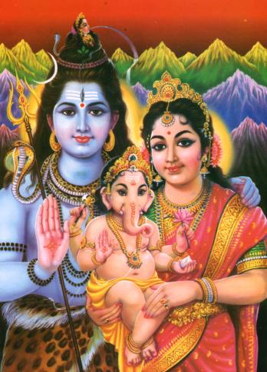
oM NAMo bhagawat vasudevaya namah

SHIV UMA GANESH MANDIR INC.
OF
95 COMMERCIAL BLVD., CENTRAL ISLIP, NY 11722


CORDIALLY INVITES

THE GENERAL PUBLIC
TO ATTEND ITS GRAND RE-OPENING
WITH A SEVEN SESSION
SRIMAD BHAGAVATA MAHAPURAN YAGNA
AND CONCLUDES WITH THE
CELEBRATION OF KRISHNA JANAM ASHTMI
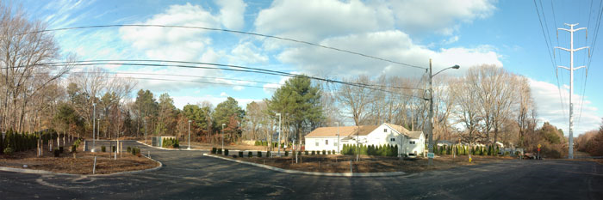
COMMENCING ON FRIDAY AUGUST 7th &
CONCLUDING ON FRIDAY AUGUST 14th 2009

SESSION AS FOLLOWS:FRIDAY 7th & SATURDAY 8th @ 7:00 -9:00 PM SUNDAY 9th @ 9:30 – 12:00 NOON, MONDAY 10th, TUESDAY 11th, WEDNESDAY 12th & THURSDAY 13th @ 7:00 – 9:00PM & FRIDAY 14th @ 7:00 – 10:00 PM

DISCOURSE BY SWAMI BAL GOPAL
ASSISTED BY PANDIT RAMSUNDAR GOBIN


FOR MORE INFORMATION, PLEASE CONTACT:
PANDIT RAMSUNDAR GOBIN 631-582-5194
BHAI MUKESH SAMAROO 631-952-2020
BHAI RANVEER GOBIN 631-582-4267
BAHAIN DESIREE KANHAI 631-234-3031
BHAI JEETLALL BEIR 631-436-7923

